Practical – 4
Study and Implement Simple Linear Regression.
- What is Linear Regression?
Linear regression is a statistical and machine learning method used to model the relationship between variables. It tries to draw a best-fit straight line through data points to predict values.
- How Linear Regression works?
Core Idea:
It assumes a relationship like:
$$y=mx+c$$Where:
- x → Input (independent variable)
- y → Output (dependent variable)
- m → Slope (how much y changes when x changes)
- c → Intercept (value of y when x = 0)
What It Does
- Learns from past data
- Finds the line that minimizes prediction error (usually using least squares)
- Uses that line to predict future values
Example: If you use linear regression to predict house price based on size, it learns how price increases as size increases.
Ways To Implement Linear Regression:
There are two ways to implement Linear Regression in Machine Learning
    - Normal Equation: It’s a pure math approach where we use maths like statistics to find the parameters to fit the data in the line.

    - Sklearn: It’s a built-in library in python which uses Ordinary Least Squares Approach to find the parameters and fit the data.

- Implementation of Linear Regression Using Normal Equation:
Step 1: Dataset Preparation
We are using Height and Weight data for this practical from Kaggle.
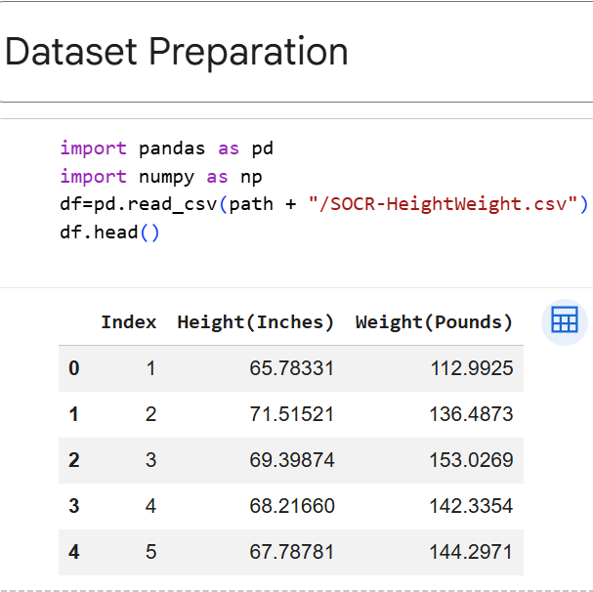
Step 2: Perform Standardization on the dataset:-

Now we write the function to use normal equation to find parameters for performing linear regression.

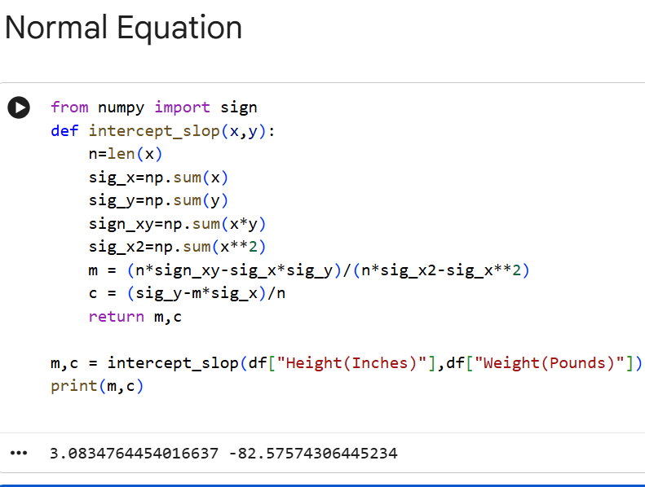

Step 3: Prediction:

Now we do the prediction of the weights for the corresponding height.

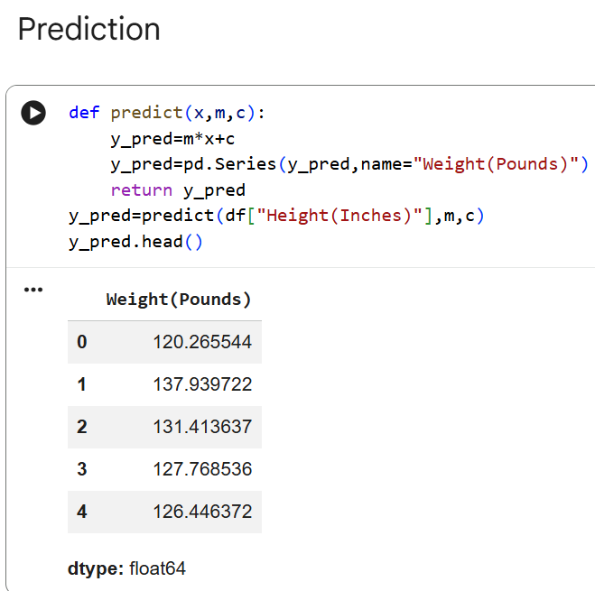

Step 4: Mean Squared Error:

Now let us calculate the mean squared error from sklearn.metrics library.

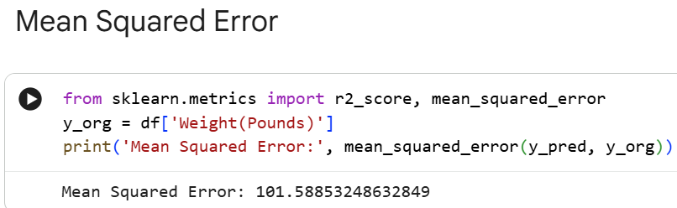

- Implementation of Linear Regression Using sklearn:

Step 1: Import the Libraries

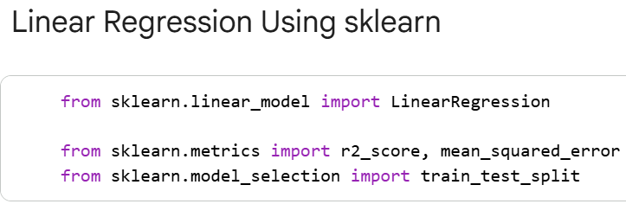

Step 2: Load The Dataset

We are using the same dataset as the one used for normal equation.

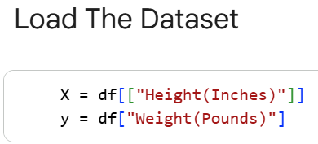

Step 3: Data Splitting and Model Training

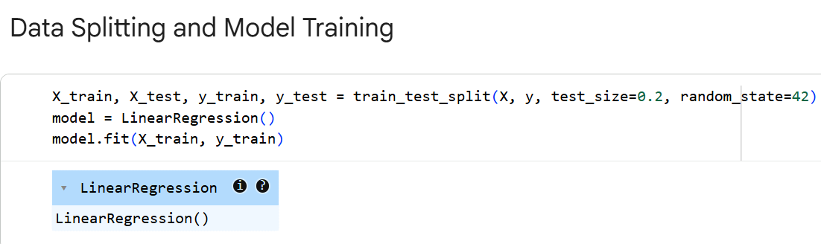

Step 4: Prediction

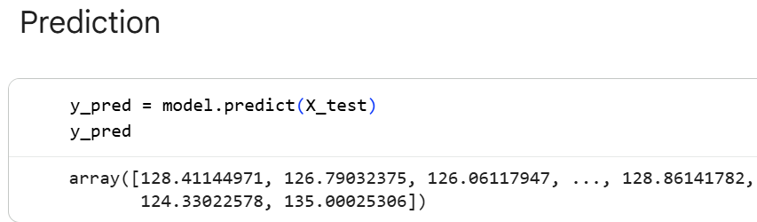

Step 5: Error Calculation

